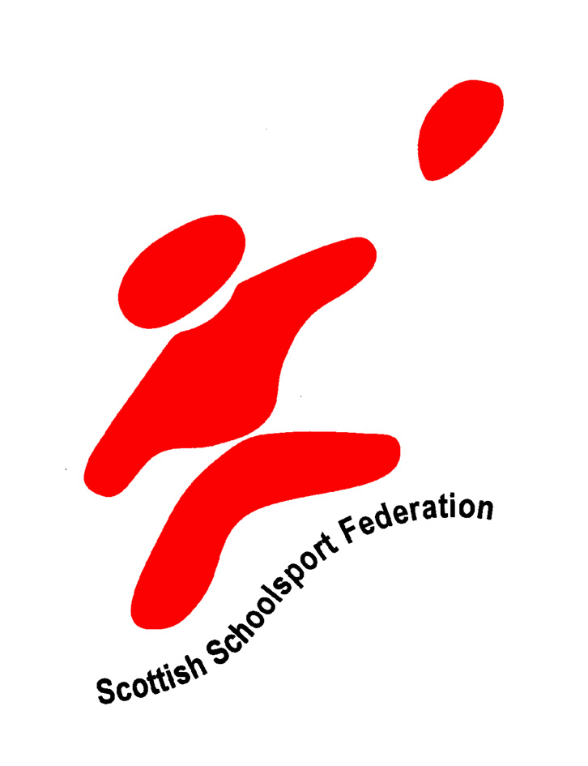



Scottish Schoolsport Federation School Sport in Scotland
Call for full review of out–of-hours school sport

It was expected that the Scottish Executive PE Review Group would report on the Out of Hours dimensions. The PE review group decided that school sport was outside its remit.

The delivery of school sport in Scotland is now a matter of serious concern. Where will the new generation of volunteers come from to take children for sport?

Full-time Active School Co-ordinators in primary clusters will undoubtedly make a difference to physical activity levels amongst primary children by increasing the volunteer base particularly amongst parents, senior pupils and others in the community. The picture is much less encouraging in the secondary school environment with fewer teachers volunteering owing to curricular restructuring, an ageing profession, decreasing self-discipline amongst children and where very few parents volunteer to assist school sport. In addition, owing to the reduction in resources given to secondary schools to allow for a greater number of full time posts in primary, the Active Schools Network now only allows for one day a week for the co-ordinator to organise and develop sport and physical activity within the secondary schools.

Clearly there is a problem in secondary age school sport. If there is no early intervention then the outlook for school sport in Scottish schools is bleak.

The Scottish Executive must as a matter of urgency review the full extended curricular provision, including Sport, and produce a rationale for that extended curriculum. The following key outcomes would represent a way forward in strengthening the place of school sport in Scotland.

KEY OUTCOMES.

- That the Scottish Executive establish a School Sport Review Group to consider and report on the practice and the delivery of all of out-of-hours school sport.

- That the School Sport Report Review Group consider measures to ensure that the recognition of teachers’ and volunteers’ contribution to school sport be recognised and rewarded through a combination of honoraria, time off in lieu, provision for staff development to develop coaching both in quantity and in quality and that these measures be nationally and consistently funded in all Local Authority areas by the Scottish Executive.

A vision for school sport in the future

Ideally there would be an extensive network of sports clubs working in partnerships with their local schools. Ideally, teachers would volunteer their time not only to coach the school children, but also take them to competitions and performance opportunities. Each school would have an extensive range of opportunities for children to participate in sport in an environment where sport is valued for its contribution towards lifelong learning, raised attainment, self esteem and achievement amongst children and for the strong contribution towards developing a positive ethos and identity for the school.

The realities of school sport

The harsh realities are that the club structures in Scotland are not at all well developed and are commonly able to cope only with their existing numbers. With the possible exception of Rugby, governing bodies and their clubs struggle to support schools. This poses the question: Who will actually take the children for the practice and the matches after school? As an example the Sports Comprehensive approach being adopted in three North Lanarkshire schools is clearly supporting more sport after school in these schools. It is not at all clear, however, who will deliver sport (in particular the practice) in the other schools in North Lanarkshire.

In Primary clusters Active Schools Co-ordinators are definitely creating more opportunities for physical activity and sport by:-

- Adopting a strategic approach
- Focusing on the recruitment and support of volunteers, teachers and coaches
- Festivals and events
- Establishing links (where possible) with clubs
- Linking with local authority sports strategies.

Secondary school sport is suffering decreasing numbers participating in competitive sport; provision must urgently be made to support sporting league structures, competitive sporting events and school sporting competitions by:

- Supporting local sports associations.
- Encouraging, supporting, and recognising the contribution of volunteers
- Encouraging sport amongst school-aged children.

Evidence on research statistics for sport is based on household surveys. It takes account of the level of activity over the previous four weeks. It is clear that for both school and community sport more evidence is required. This evidence should differentiate between performance/competition and training/practice. In schools continuing research is required in order to demonstrate the link between school sport and the Raising Attainment and Achievement agendas.

The contribution made by school sport in the extended curriculum must also be considered for its contribution to the National Priorities for Education specifically for the contribution towards lifelong learning, citizenship and achievement amongst school children.

Following review any policies and practices devised to improve the situation of school sport must be uniformly applied across all the schools in the country.

Current financing of physical activity and sport

- The Big Lottery Fund ‘PE and Sport’ resources are also supporting delivery, however the funding period is due to end in less than two years time. This is a real concern.

The Active Schools Network in both the primary and secondary has a focus on recruiting and supporting volunteers, teachers and coaches but this is proving to be more difficult in the secondary sector. The real problem for school sport is now the ‘delivery’ of sport in schools

- Time-limited funding initiatives such as the Big Lottery Fund Out of School Hours Activities only provide a short-term solution to a long-standing problem. In many ways this type of funding has ultimately a negative impact on staff. Where coaches have been paid to deliver sport, volunteers and teachers are understandably reluctant, once the funding runs out, to continue their extra-curricular commitment unrecognised and unrewarded.

- Professionals find it very disappointing that colleagues in schools are being paid for out-of-hours school learning schemes, running study classes where small numbers of pupil attend yet teachers involved in after-school sport and physical activity club organisers can have up to 30 pupils under their care and receive nothing!

- It is particularly disappointing for members of staff, particularly the PE staff, who currently receive no financial recognition. We feel that Head Teachers should implement a policy that acknowledges and recognises the hard work and dedication put in throughout the year on extra-curricular sporting activities.

In addition the Scottish Executive has radically increased its financial support for various other Out of School Activities:
Out-of-Hours Learning/Study Support (include homework clubs, subject specific teaching).
After School Clubs (these are often found in primary schools in the more deprived areas).
Music Instruction (funded to a level of £17m over the next 3 years). Some of this money is being used for Out of School Music.

These funded programmes create a very uneven and unbalanced competition for school sport, which will largely depend on volunteers for its delivery.

The role of the Scottish School Sport Federation

The Scottish School Sport Federation (SSF) has restructured its organisation to reflect the impetus created for school sport in Scotland by both the development of the Active Schools Network, driven forward in partnership by sportscotland and local authorities, and the Big Lottery Fund PE and Sport Programme.

Local Authorities representatives are now an integral part of the membership of the SSF and will play a vital role in developing school sport at local level. It is envisaged that the school sports associations will assist in the development of the sport by establishing appropriate performance opportunities at local and national level and by offering teacher and coach development opportunities. The SSF is keen to establish local federations, perhaps in each local authority, to support local events and local developments. It is clear that at both local and national level a scheme to support these federations similar to the existing national Teacher Release Scheme (established by SSF) which supports national/local events, local/national representation, and also sport specific development needs to be created. The current national scheme is funded by the Scottish Executive through sportScotland (£50,000). SSF feels that this current scheme requires modification and further expansion.

Following consultation and discussion at the SSF Executive meetings the SSF representing school sport associations and local Authorities recommends that any review group set up to review school sport should consider the following suggested improvements to school sport in Scotland

The role of sportScotland
SSF currently are developing and building stronger relationships with sportScotland, who share the view of SSF that the support of volunteers in the area of school sport is critical to the provision of future school sport opportunities for our young people.

Recommendation 1:

The current Teacher Release Scheme requires modification, expansion and funding

Recommendation 2:

Local Authorities should consider establishing local sports associations, which facilitate festivals, competitions and performance opportunities and support teacher/parent education.

Recommendation 3:

That the Scottish Executive establish and develop base line research information about school/sports participation.

Recommendation 4:

That an honorarium of £250 be paid to every member of staff who takes an extra curricular club. This will be determined by a set number of hours to be worked (per term) prior to qualification for the honorarium, for example 20 hours per term. Head Teachers can decide to pay above this threshold but this figure must act as a minimum base line amount. If staff are currently receiving £17 per hour for any extra-curricular work the Head Teacher can still maintain this level of funding by paying the equivalent via an honorarium.
- The amount of the honorarium to be standard across Scotland and all Head Teachers agreeing upon this figure.
- The number of hours to be set which a member of staff has to work to qualify for the honorarium.
- If a standard payment time throughout the year needs to be established or if it is to be left to the Head Teacher to decide when staff receive the payment.
- A date by which all secondary schools in Scotland action the agreed policy.
- Communication with staff involved particularly the Active School Co-ordinator on ways of successfully implementing the policy.
- That coach development opportunities be expanded to support, recognise and reward the contribution made by teachers and volunteers to school sport.

Recommendation 5:

That initiatives be pursued which increase significantly the number of teacher hours devoted to the delivery of school sport and physical activity. That for example a proportion of the contracted hours of teachers be allocated to support extra-curricular school sport. Head Teachers and their staff recognise this potential and identify time within contract, for teachers to support such school activities. For example, teachers could take responsibility for accompanying school teams to events. Alternatively that time off in lieu schemes or local teacher release schemes be developed and that funding be provided to support such initiatives.

Summary

The SSF presents this document for consideration to the Scottish Executive.

We strongly urge the Scottish Executive to establish a review group to examine thoroughly the position of school sport in Scotland taking into account the recommendations outlined above.

